J.B. Morris

Dr. John Dionisio

CMSI 370

25 November 2014

System Type:

Ubiquitous computing involves creating a system that exists around the user and inhabits the space and objects in the environment. This "internet of things" lends itself to adding intelligence to objects we use in our daily lives. Ubiquitous computing, however, is not necessarily meant to be a replacement for desktop computing as we know it today: it simply adds convenience to everyday tasks and provides basic assistance to users. An important aspect of this approach is its unobtrusiveness. Ubiquitous devices cannot overwhelm users with information or become overly involved with the user so that they must constantly need explicit user input. Some of the major challenges to ubiquitous computing that I hope to address are its ability to acquire information implicitly, the AI necessary to process user input intelligently and accurately, as well as the practicality of installing such a system in a home environment.

Design layout:

My proposed system will use a series of independent components that that communicate with each other through the user's home wireless network to create a smarthome environment. The components within the system may be added separately and over time as the user acquires them. The system, then, can be tailored to a variety of different users and households as needed. At a basic level, the system offers basic control over electronics within the smart environment through natural speech interaction or menu based interaction through a separate device. As components are added, the system's sensory abilities increase and allow for passive user input (such as the system being aware of each user's location within the environment) and awareness of the status of the environment itself (amount of water left in a pitcher or eggs in the refrigerator).

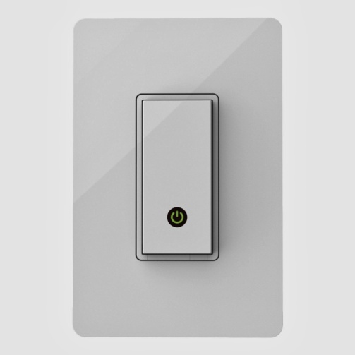The backbone of this smart home system relies on a network of light switches and power outlets that each have their own connection to the homeowner's WI-FI network. Each of these is equipped with a microphone (and can be equipped with other sensors for temperature, air pressure, light, and humidity should the user choose to do so) and can be controlled either by voice commands, through the wireless network (utilizing a tablet, phone, or computer), or the physical switch. The entire system is connected to a main computer or main cluster of computers that can get user input from any of the smart items within the house. In addition to the switches and outlets, the system will also incorporate a WI-FI based sound system that allows the system to give responses to the user. To give the system access to other technology heavy areas of the house, such as the living room, accessories such as automated television controls that utilize infrared to operate common media devices in place of a remote or a Kinect-like device can be added to minimalize the need for the user to utilize other, proprietary tools. This ubiquitous interface is designed to present the user with complete control over his or her living environment from any location, while providing assistance to the user(s) within the environment at their request. While the system heavily utilizes natural language for basic functions, it leaves the more detailed tasks to a menu based graphic user interface that can be accessed through displays within the household, smart phones, tablets, or wearable devices. Specifically wearable accessories such as a clip on microphone or app to integrate with smart watches could increase learnability and efficiency while reducing user errors.

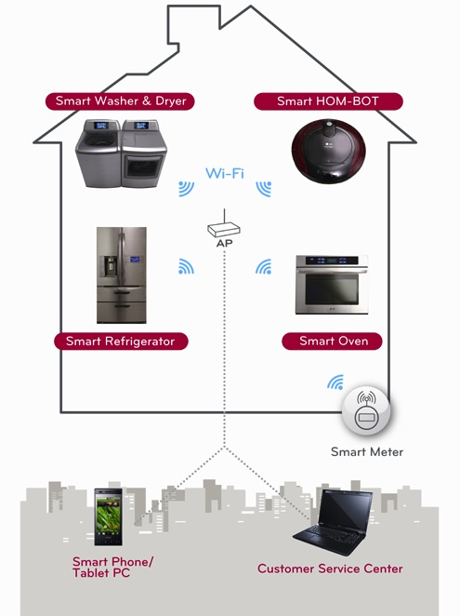 Finally, specialty items can be added to the system for specific user needs. Special appliances, for example, can be added to the network and be controlled and provide feedback remotely. These specialty additions allow for passive communication that can help the system respond more intelligently to the user. If the user leaves the household, he or she may receive a notification from the system to purchase certain groceries or that they left an appliance on and prompt him or her to turn it off remotely. Wearables, especially, will enable the system to act intelligently as the devices can communicate with the system constantly and passively about the location of the user, current activity, and health statistics. Combined with the Kinect and other sensors that a user has added to the environment, a wearable could also be used for gesture based input. For the purposes of this paper—as I am focusing on the ubiquitous computing aspects of this user interface—assume that the standard GUIs associated with the Kinect or other smart devices that interact with the system use the default layouts or mimic the default layouts native to them.

Usage Scenarios:

Beyond the confines of the smart home, the user communicates with the system through an outside device such as a smart phone or tablet. The user would be able to view the status of their home through cameras, temperature sensors, motion detectors, door sensors, and other devices. Based on this information, the user may then choose to make changes remotely or program the system to do so automatically. For example, if the user gets a notification that there is movement around the house from the security system, he or she may choose to remotely turn on the lights, TV, and sound system in the living room to deter the potential burglar before the police arrive. For everyday purposes, a user may choose to have a song being to play as they open the front door after coming back from work, maybe even pairing it with specific lighting and temperature settings.

Within the smart environment, the interface is designed to allow the user to use voice and gesture based commands to interact with the system like one would a personal assistant. In the kitchen, for example, the user could initiate communication with the interface with a trigger phrase—like "ok Google"—and ask about a recipe for a dish they want to prepare. The system could then respond vocally, listing off all the ingredients and preparation steps to the user. For large exchanges like this, the user could prompt the system to provide a transcript of their conversation on any particular screen in the house, including tablets, smart phones, and wearables. Each screen can be equipped either with a touch screen or a Kinect to allow the user to utilize a graphic interface should they need to.

Rationale:

This smart home layout relies heavily on vocal commands for the majority of its basic functions. However, complete reliance on natural language interaction, according to Shneiderman, is prone to miscommunication. Additionally, complex menus that must be navigated through natural language communication force a heavy memory load on the user. As such, the system utilizes a graphic user interface for the more complicated and specialized tasks or as a backup when natural language communication fails. That being said, the vocal commands will all be very much based in domain knowledge, making communication with the system for basic tasks very easily. An interface on the same level as Siri is more than capable of this, especially when combined with the customization offered in the IFTTT app.

Aside from explicit user input, the more specialized items within this system lend themselves to implicit data collection. Context awareness, as highlighted by John Krumm in *Ubiquitous Computing Fundamentals*, plays a large part in his "ten rules for ubiquitous user interface design," particularly in the areas of "distraction" and "calming." Contextual awareness will reduce user errors and allow for more accurate functionality within the environment.

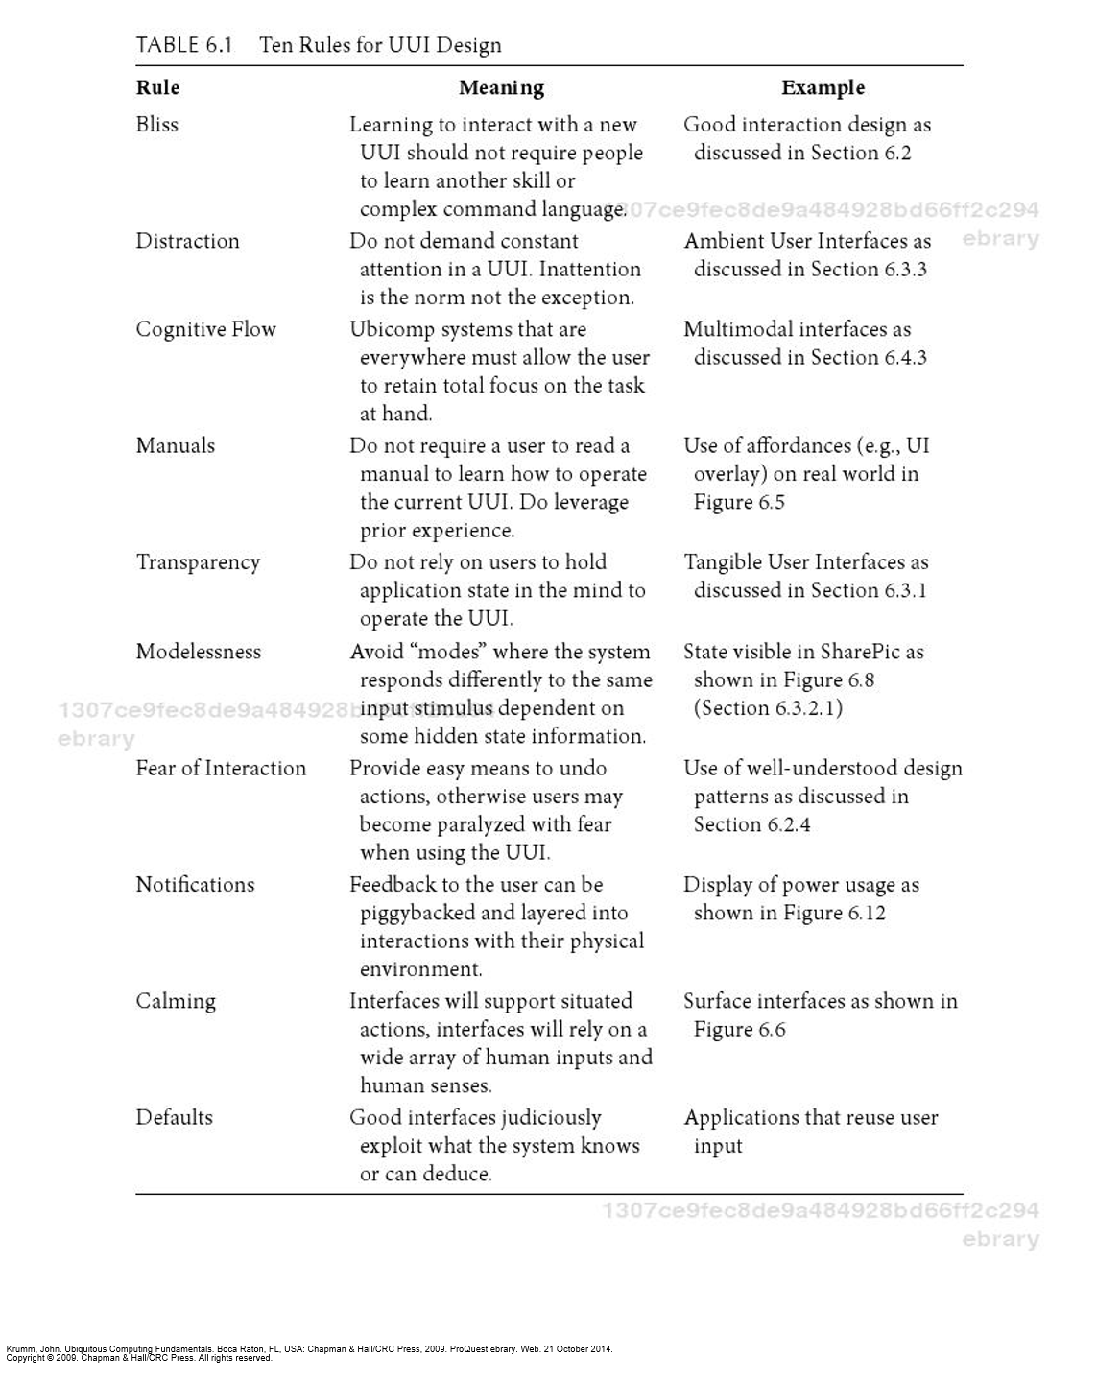

The secondary use of GUIs is deliberate as reliance on them would clutter the environment and prevent the user from being able to function within the environment without distraction in accordance with the "cognitive flow" while simultaneously providing a failsafe for the user should they encounter problems with natural language communication—which helps to further fulfill the "fear of interaction" rule.

Usability metric forecast:

I believe that the natural language interface will perform well in the areas of learnabiliy, efficiency, and memorability. Natural language interfaces, such as the ones implemented in smart phones today, take advantage of the user's domain knowledge in order to provide an easy learning curve. As for errors and satisfaction, I don’t foresee those two metrics performing very poorly but I do see a possibility for them to receive lower scores. Unlike a smart phone, a ubiquitous computing environment's uses are much less focused and the user's expectations may exceed its capabilities. This would directly affect the satisfaction metric as well, but not heavily.

The GUI aspects of the system would likely have lower learnability, efficiency, and memorability scores than the natural language interface. This can be attributed to the expanded capabilities that will come along with the GUI that add a higher level of complexity that will likely manifest itself with potentially long lists of options and menus for the user to navigate. However, I believe the graphic user interface will be less prone to errors and that the aforementioned scores would increase once users become more experienced.

Technology utilized:

Belkin WeMo light switch

Google Chromecast

Sonos Sound system

Bang and Olufsen Home Integration

Microsoft Xbox Kinect

IFTTT

Siri

SmartThings components

Works Cited:

Genco, Alessandro, and Sorce, Salvatore. Pervasive Systems and Ubiquitous Computing. Ashurst, GBR: WIT Press, 2010. ProQuest ebrary. Web. 21 October 2014.

Goodwin, Steven. *Smart Home Automation with Linux*. New York: Apress, 2010. 1-303. Print.

Krumm, John. Ubiquitous Computing Fundamentals. Boca Raton, FL, USA: Chapman & Hall/CRC Press, 2009. ProQuest ebrary. Web. 21 October 2014.

Poslad, Stefan. Ubiquitous Computing : Smart Devices, Environments and Interactions. Hoboken, NJ, USA: John Wiley & Sons, 2009. ProQuest ebrary. Web. 21 October 2014.

Scholtz, Jean, and Sunny Consolvo. "Towards a Discipline for Evaluating Ubiquitous Computing Applications." (2004): 1-18. Intel Research. Web. 1 Oct. 2014. <http://intel-research.net/Publications/Seattle/022520041200_232.pdf>.

Yang, Laurence Tianruo, Syukur, Evi, and Loke, Seng. Handbook on Mobile and Ubiquitous Computing. London, GBR: CRC Press, 2012. ProQuest ebrary. Web. 21 October 2014.